FARMHOUSE IN BRITTANY, FRANCE
LES VOLETS VERTS, ST. REGENT
Sleeps 8
7 Days
(at a mutually agreed time)

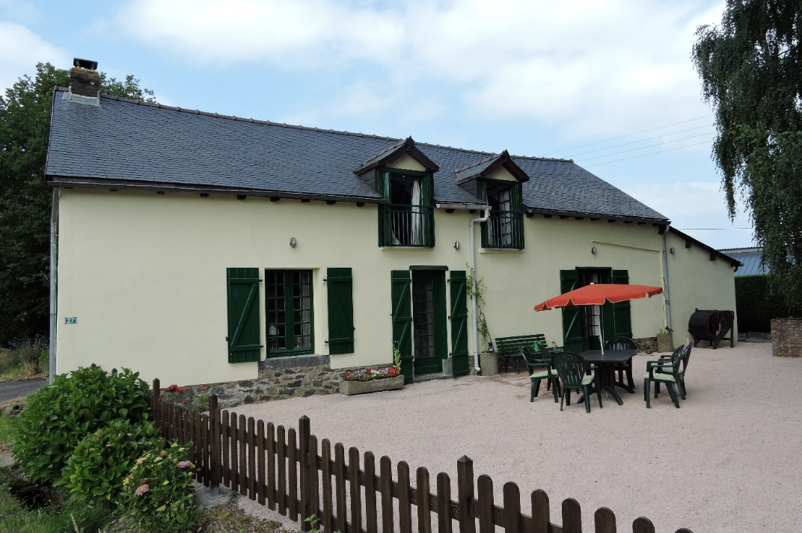
Spacious, comfortable & peaceful family house in rural Brittany.
Coast and many sights within one hour’s car ride:
Medieval Dinan 25 minutes • Dinard/St. Malo 55 minutes
Rennes 30 minutes • Mont St Michael 60 minutes.

ACCOMMODATION
Ground Floor: Kitchen with washing machine.
Dining room with large dining table.
Sitting Room with wood burner.
Family Bathroom with bath, shower & loo.
First Floor: 2 Double Bedrooms
Family Bedroom with 2 single beds and 2 bunk beds.
Loo & Basin.
Outside: Large garden front and back plus a field. Good for games.
BBQ.

